Report on BLE module

Dated: 12-09-2024

The module which we have for BLE incorporates CC2541, which is **Bluetooth® Low Energy system-on-chip (SoC) solution** by Texas Instruments. There are multiple variants of BLE module made by different manufacturers. The module we have is CC41-A (this is clone of HM-10).

Since we don’t have CC debugger or smartRF Flash programmer, we will use AT commands to configure CC41 as a iBeacon.

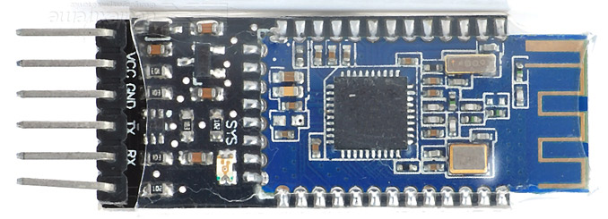



HM-10 front

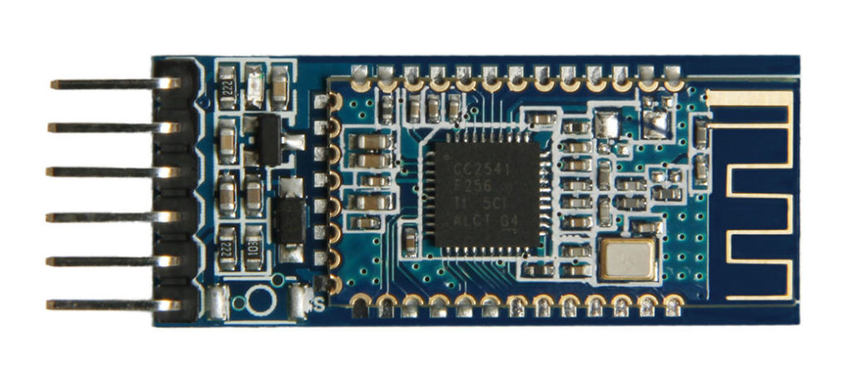



CC41-A front

The main difference between CC41-A and HM-10 is number of oscillators. CC41 only has one oscillator where HM-10 has two. Unfortunately the [HM-10 AT commands](https://fab.cba.mit.edu/classes/863.15/doc/tutorials/programming/bluetooth/bluetooth40_en.pdf) are different from CC41 AT commands (You can get list of supported AT commands by using AT+HELP). Specifically, the CC41 is less documented and the command set and available functionality are poorer.

Main differences include:

* Case-sensitivity.
* End-of-line termination, with HM-10 expecting no new-line or carriage-return while the CC41 expects both.
* Different command names, such as VERS vs VERSION.
* Different command syntax, such as using a ‘?’ for queries or not using any special character

Using AT commands on CC41

Requirements

Hardware: CC41, FTDI TTL converter, F-F jumpers

Software: Serial Terminal like Coolterm ([download](https://coolterm.en.lo4d.com/download)) which supports Line mode terminal (putty doesn’t support it).

Connections:

Make connections as per following table

|  |  |
| --- | --- |
| **FTDI** | **CC41** |
| 3v3 | Vcc |
| GND | GND |
| RXD | TXD |
| TXD | RXD |

Connect FTDI to your PC.

Go to device manager and look for port of FTDI.

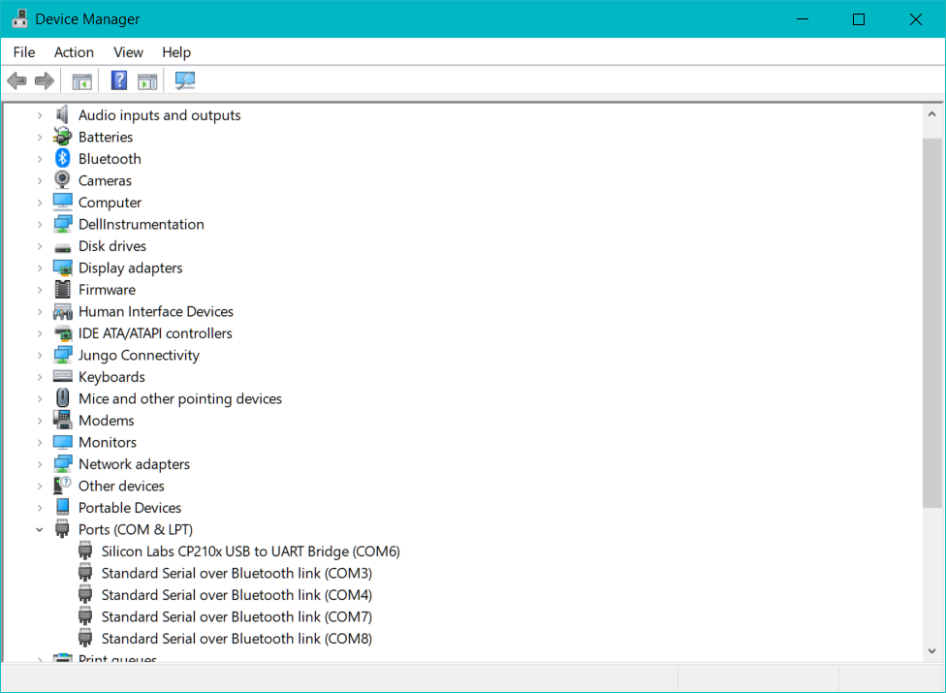



Use this COM6 in Coolterm to establish connection with CC41 using FTDI.

In coolterm, go to options and set Serial port, baud rate, etc.

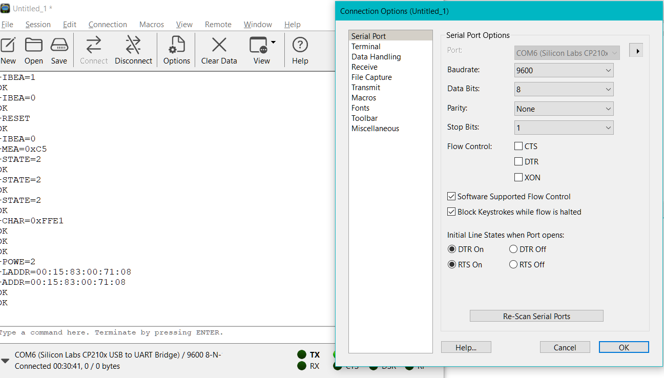



And then terminal to Line mode to get response for AT commands.

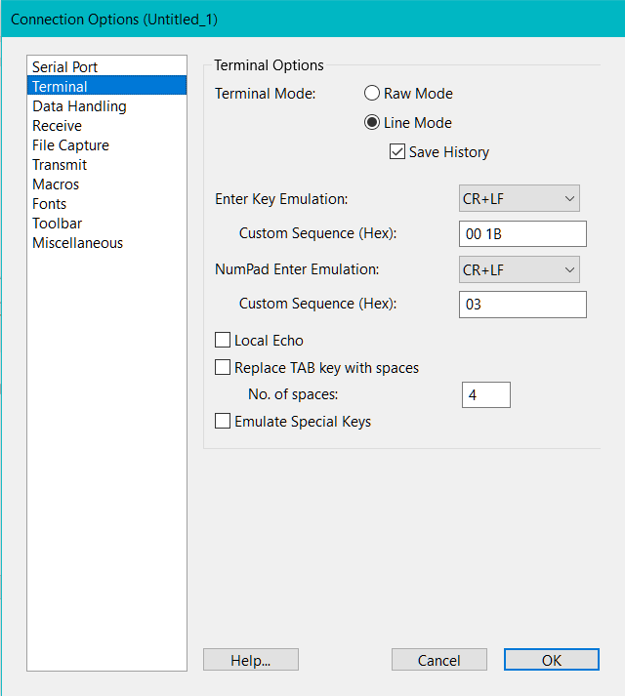



Then connect to serial port and send AT. Output response should be OK.

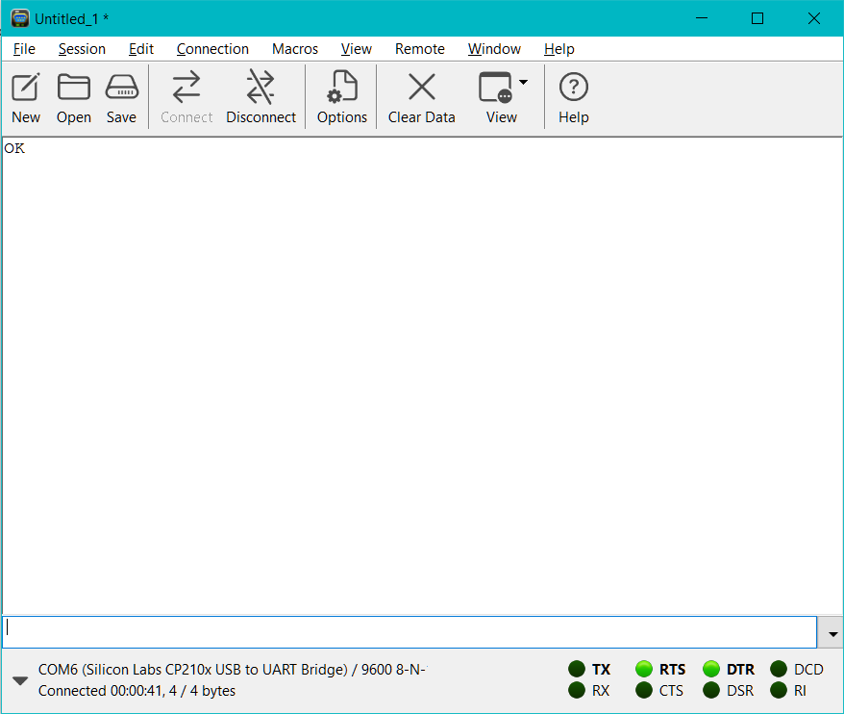

Insert AT commands here and hit enter



Now to configure you CC41 as beacon enter following commands.

To put the device into iBeacon mode, lets first lets restore factory defaults:  
AT+RENEW  
AT+RESET

Set major and minor numbers in hex:  
AT+MARJ0x0539  
AT+MINO0x0001

Set device name:  
AT+NAMEPLAYER0001

(Replace your beacon name with PLAYER0001, this name will also be visible in mobile phone’s Bluetooth scan)

This one is interesting, since it is part of the HM10 commands, but not documented with the Bolutek module, the advertising interval. By default, this is set to 9 (1285ms), but I want it to advertise more often and set it to 0 (100ms):  
AT+ADVI0

And finally switch to iBeacon mode and reset the device:  
AT+IBEA1  
AT+RESET

Response to these AT commands should like below.

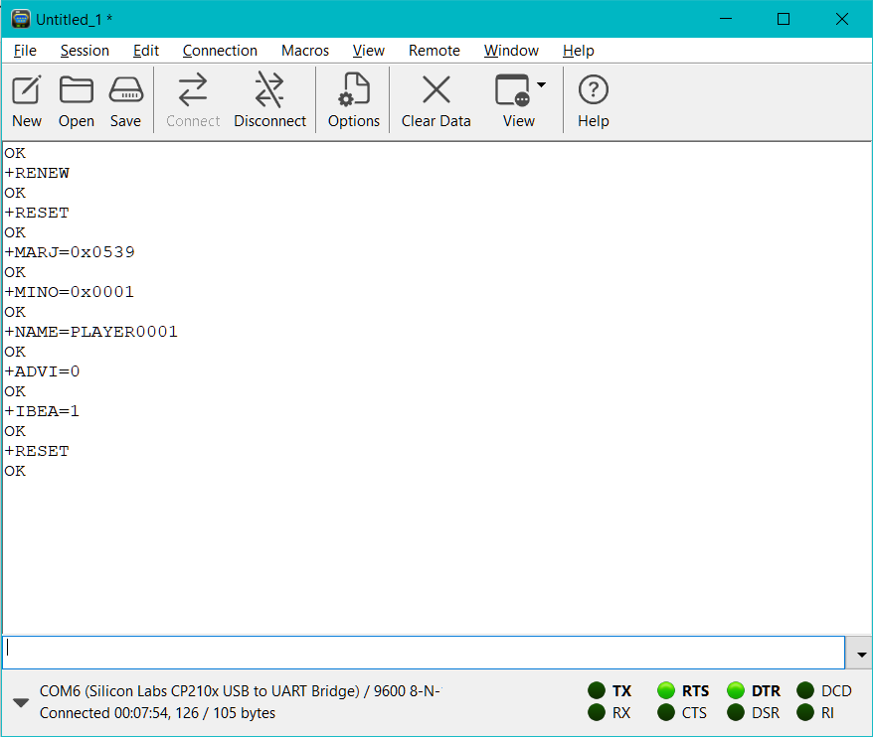

Now you can check mobile’s Bluetooth scan. There should be a discovered device called “PLAYER0001”.

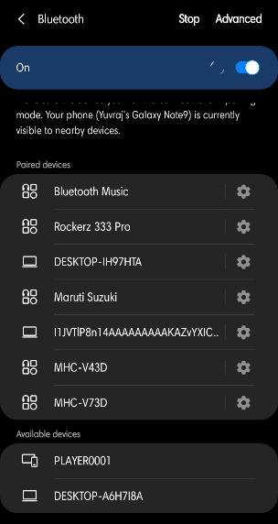



If your phone doesn’t support BLE device discovering, it will not be visible here.

To check beacon’s broadcasted message, you need to download any Beacon scanner android application. I am using NanoBeacon BLE Scanner. In this app, you can apply filter which comes handy.

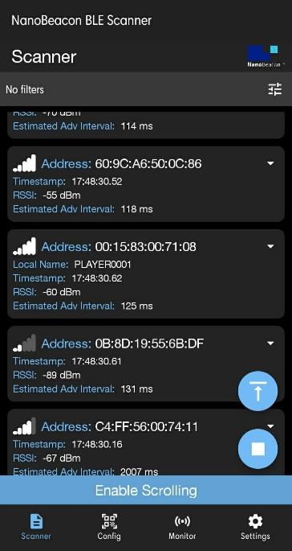

You can see beacon with name PLAYER001 is detected.



You can apply filter to search beacon more efficiently.

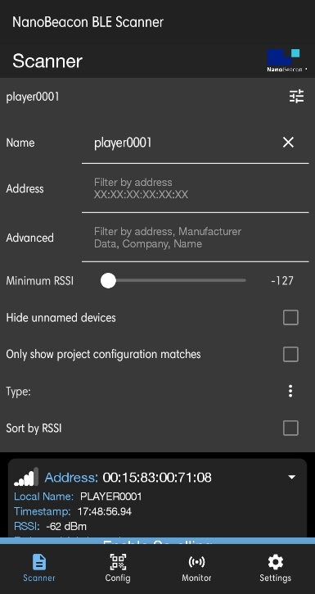

Data broadcasted by beacon is

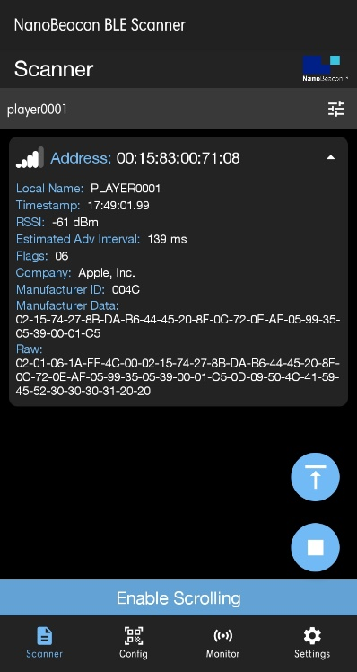



Here in highlighted area, you can see Major and Minor numbers that we entered using AT commands. Also estimated advertising interval is similar to somewhat that we assigned using AT command.

Since CC41 is clone of HM-10 it doesn’t all the functionality of HM-10 like broadcasting GPIO Pins status, etc.

References:

1. [BLE-CC41-A (HM10 clone) iBeacon](https://rememberdontsearch.wordpress.com/2017/04/19/ble-cc41-a-hm10-clone-ibeacon/)
2. [Comparing the HM10 and BLE CC41a Bluetooth](https://rydepier.wordpress.com/2015/10/22/comparing-the-hm10-and-ble-cc41a-bluetooth/)
3. [iBeacon using an HM10 or CC41A Bluetooth 4 Unit](https://rydepier.wordpress.com/2015/10/24/ibeacon-using-an-hm10-or-cc41a-bluetooth-4-unit/)